Sentiment Analysis of Union Budget 2025
Project Synopsis Report
Submitted in partial fulfillment of the requirements for the degree of
BACHELOR OF TECHNOLOGY
in
CSE with Specialization (AI/ML)
to
K.R Mangalam University
By
Rudraraj Radhwani (2401731349)
Dhruv Arora (2301730337)
Amay Yadav (2301730311)
Yuvraj Rathi (2301730334)

Under the supervision of
Mr. Ashwani Kumar

Department of Computer Science and Engineering School of Engineering and Technology
K.R Mangalam University, Gurugram- 122001, India January 2025
CERTIFICATE

This is to certify that the Project Synopsis entitled, “Sentiment Analysis of Union Budget 2025” submitted by “Rudraraj Radhwani(2401731349), Dhruv Arora (2301730337), Aamy Yadav(2301730311) and Yuvraj Rathi(2301730334)” to K.R Mangalam University, Gurugram, India, is a record of Bonafide project work carried out by them under my supervision and guidance and is worthy of consideration for the partial fulfilment of the degree of Bachelor of Technology in Computer Science and Engineering of the University.

Type of Project (Tick One Option)
Industry/Research/University Problem

<Signature of Internal supervisor>
Mr. Ashwani Kumar
Assistant Professor, CSE

Signature of Project Coordinator

Date: 3rd April 2025

INDEX
S.No. | Topic | Page No
1. | Abstract
2. | Introduction
3. | Motivation
4. | Literature Review/Comparative Work Evaluation
5. | Gap Analysis
6. | Problem Statement
7. | Objectives
8. | Tools/Platforms used
9. | Methodology
10. | Experimental setup
11. | Evaluation Metrics
12. | Results and Discussion
13. | Conclusion and Future Work
14. | References

ABSTRACT
The Indian Union Budget is a highly anticipated annual event that directly impacts the economy, industries, and individual citizens. With the rise of digital platforms and social media, public responses to the budget are now more immediate and widespread than ever before. This project focuses on analysing these responses using Natural Language Processing (NLP) and Machine Learning (ML) techniques to understand the overall sentiment surrounding the Union Budget 2025.
The primary goal is to capture and interpret public opinion by analysing textual data collected from diverse sources such as Twitter posts, news headlines, and financial blogs published shortly after the budget announcement. These sources offer a mix of personal, political, and economic perspectives, making them ideal for sentiment evaluation.
The methodology includes data preprocessing (tokenization, removal of stop words, lemmatization), followed by the use of sentiment analysis tools like VADER (Valence Aware Dictionary and Sentiment Reasoner) and TextBlob, which help classify each text as positive, negative, or neutral. The processed data is visualized using tools like Matplotlib and Seaborn, helping to highlight trends, peaks in sentiment, and responses to key policy areas such as taxation, subsidies, defence, education, and health care.
The project also attempts to correlate public sentiment with specific budgetary announcements, revealing which sectors or policies received favourable or critical feedback. These insights can be valuable for economists, policymakers, investors, and media analysts to gauge the success of the budget from a public relations and impact standpoint.
KEYWORDS: Sentiment Analysis, NLP, Machine Learning, Artificial Intelligence

Introduction

- Background of the project

The Indian Union Budget is a crucial annual statement presented by the Government of India, outlining the expected revenue and expenditure for the upcoming financial year. It is not just a financial document—it acts as a reflection of the government's policy direction and socio-economic priorities. The Budget impacts every citizen and industry, and the public's reaction can reveal much about its reception.
With the increasing penetration of the internet and smartphones, social media platforms like Twitter and financial blogs have become primary spaces for public discourse. These platforms reflect immediate and candid public opinions, both positive and negative. Capturing and analyzing this massive amount of unstructured text manually is impractical—hence the need for automated sentiment analysis using NLP and machine learning (ML) techniques (Table 1).
This project aims to harness the power of NLP to process and interpret thousands of budget-related comments to reveal prevailing public sentiments and trends. These insights can inform media analysts, policymakers, and economists about how the budget has been perceived at scale.
Table 1: Key Details and Data Sources Used in the Project
S. No. | Component | Details
1. | Event | Indian Union Budget 2025
2. | Objective | To evaluate public sentiment regarding the budget using NLP
3. | Data Sources | Twitter posts, Financial news headlines, Reddit discussions, Blogs
4. | Data Type | Unstructured Text
5. | Techniques Used | NLP (Tokenization, Lemmatization), Sentiment Classification (VADER, TextBlob)
6. | Tools & Libraries | Python, Pandas, NLTK, TextBlob, VADER, Matplotlib, Seaborn
7. | Expected Outcome | Categorized sentiment trends (Positive, Negative, Neutral), Word Clouds
8. | Impact | Understanding public perception, aiding policy feedback

MOTIVATION

In a democratic society like India, public opinion plays a pivotal role in shaping governance and influencing future policies. The Union Budget is one of the most critical annual events, as it directly impacts the financial wellbeing of individuals, businesses, and the nation at large. Citizens eagerly assess the budget for reforms in taxation, investments in public infrastructure, subsidies, welfare schemes, and sectoral priorities such as education, healthcare, and defense.

Despite the budget's significance, traditional methods of gauging public opinion—such as opinion polls, media editorials, or expert panel discussions—are often time-consuming, limited in scale, and subject to bias. Moreover, they fail to capture the spontaneous, diverse, and real-time reactions that citizens share online. This gap in understanding the collective mood of the public, especially from diverse social and economic backgrounds, calls for more innovative, data-driven solutions.

This project is motivated by the belief that technology can enable more inclusive and dynamic feedback mechanisms. By leveraging Natural Language Processing (NLP) and Machine Learning (ML), it becomes possible to process and analyze thousands of public comments, tweets, headlines, and discussions in real time, providing a clearer picture of how the Union Budget has been received.

Key drivers of motivation behind this study include:
- Understanding Public Sentiment on Economic Matters: From tax rebates and fuel prices to job creation and subsidies, budget decisions trigger emotional and intellectual reactions. Analyzing sentiment provides insights into public priorities, helping policymakers understand what citizens value most.
- Bridging Academia with Real-World Events: As a Computer Science and Artificial Intelligence student, this project provides a unique opportunity to apply theoretical concepts like NLP, data preprocessing, sentiment scoring, and visualization techniques to a large-scale, real-world problem.
- Contributing to Smarter Governance: If implemented on a larger scale, such projects could provide automated, scalable, and unbiased public opinion dashboards that ministries or think tanks could use for strategic planning and course correction.
- Amplifying Public Voice: The power of sentiment analysis lies in its ability to convert mass opinions into structured insights. This amplifies the collective voice of citizens, empowering them to indirectly influence policy narratives and priorities.

In essence, this project stands at the intersection of technology, society, and governance, showcasing how data science can be an enabler of transparency, inclusivity, and accountability in public decision-making

LITERATURE REVIEW

Sentiment Analysis
Sentiment Analysis (SA), also referred to as opinion mining, is a Natural Language Processing (NLP) technique used to determine the emotional tone behind a body of text. It is widely used to understand public sentiment, monitor social media trends, and gauge customer feedback. Researchers like Pang and Lee (2008) have laid the foundation for sentiment analysis by utilizing supervised machine learning models such as Naive Bayes and Support Vector Machines to classify text into positive, negative, or neutral sentiments(Table 2).
Sentiment Analysis in Budget-related Discussions
Previous studies have indicated that financial documents, including budget announcements, strongly influence public perception and market behavior. Applying sentiment analysis to Union Budget-related tweets helps in extracting the general opinion of citizens, economists, and analysts. This provides real-time feedback that traditional surveys often fail to capture promptly (Kouloumpis et al., 2011).
Data Preprocessing Techniques
Text data from social media platforms like Twitter is highly unstructured and noisy. Data cleaning practices such as removal of URLs, mentions, hashtags, special characters, and stopwords are critical. In this project, preprocessing was achieved using regular expressions (RegEx) and the NLTK library, as consistent with methods proposed by Eisenstein (2013).
Sentiment Polarity Detection using TextBlob
TextBlob, a Python-based NLP tool, simplifies tasks such as tokenization, part-of-speech tagging, and sentiment analysis. It computes a polarity score ranging from -1 (most negative) to +1 (most positive). Researchers have leveraged TextBlob for lightweight, rule-based sentiment classification where deep learning models are unnecessary (Loria, 2018).

Feature Extraction using TF-IDF
Term Frequency-Inverse Document Frequency (TF-IDF) is a commonly used method to represent text data in numerical form. It assigns weights to words based on their importance within a corpus. Salton and Buckley (1988) introduced this technique to enhance the retrieval of relevant documents, and it remains pivotal in modern text classification tasks.
Machine Learning Models for Sentiment Classification
Logistic Regression, a simple yet powerful supervised learning algorithm, is widely used for binary and multiclass text classification. It has been proven effective in scenarios where the input features are sparse and high-dimensional, such as TF-IDF vectorized data (Genkin et al., 2007). This project utilizes Logistic Regression for classifying tweets into positive, negative, and neutral sentiments.
Visualization Techniques
Visual exploration of data plays an important role in understanding sentiment distribution and trends. The project employed libraries such as Matplotlib and Seaborn to generate bar plots, pie charts, and box plots. Additionally, WordClouds were used to visualize the most frequently occurring words in positive and negative tweets, as advocated by earlier works in the visualization of textual data (Heimerl et al., 2014).
Emotion Analysis and Multi-class Sentiment Detection
Beyond simple polarity classification, detecting finer-grained emotions such as anger, sadness, happiness, and fear can enrich the analysis. By using datasets mapping text to emotional categories and employing Label Encoding, this project attempts to identify multi-emotional dimensions, resonating with Plutchik’s Wheel of Emotions model (Plutchik, 1980).

Table 2:Literature Review
Author | Year | Title / Study Area | Techniques Used | Insights / Results
Pang & Lee | 2008 | Sentiment Classification using ML Models | Naive Bayes, SVM | Established foundational ML models for classifying movie reviews into sentiment classes. Applied widely in early sentiment analysis studies.
Kouloumpis et al. | 2011 | Analysing Twitter Sentiment | Hashtag-based annotation | Demonstrated the usefulness of Twitter data for real-time sentiment tracking, particularly for public events and policy reactions.
Eisenstein | 2013 | NLP on Social Media Text | Preprocessing, Tokenization | Highlighted the challenges and techniques for cleaning noisy text from Twitter, such as removing slang, hashtags, and emojis.
Loria | 2018 | TextBlob: Simplified NLP Tools | TextBlob Polarity, Rule-based Classification | Introduced TextBlob for lightweight sentiment analysis with simple APIs for polarity and subjectivity detection.
Salton & Buckley | 1988 | Vector Space Models for Text | TF-IDF, Term Weighting | Proposed TF-IDF to weigh word importance across documents, now a core feature extraction method in text classification.
Genkin et al. | 2007 | Text Classification using Logistic Regression | Logistic Regression, Feature Selection | Proved Logistic Regression effective for high-dimensional text features, supporting its continued use in document-level sentiment tasks.
Heimerl et al. | 2014 | Visualizing Text with Word Clouds | Word Cloud Generation | Showcased how visual tools like WordClouds can make large-scale text insights more interpretable to non-technical audiences.
Plutchik | 1980 | Emotion Classification Model | Plutchik’s Emotion Wheel | Offered a psychological framework to analyze sentiment beyond positive/negative into complex emotions (e.g., anger, joy, fear).

These studies emphasize a few important trends:
- Twitter is a valuable source of real-time public opinion on economic events like the Union Budget.
- TF-IDF vectorization and Logistic Regression were used for efficient and accurate sentiment classification.

Overall, the existing literature highlights the feasibility and usefulness of sentiment analysis in understanding budget perception. However, these studies are often limited in scope—focusing on a single data source or failing to integrate real-time analysis, which presents a clear opportunity for improvement.

GAP ANALYSIS
While existing literature in the domain of sentiment analysis on the Indian Union Budget has made significant contributions, several critical gaps remain unaddressed. These gaps limit the effectiveness and applicability of such studies for real-world policy feedback and decision-making.
A GAP Analysis helps identify these missing links and frames the scope for this project. Below is a detailed breakdown of the observed gaps and their implications.
These gaps represent an opportunity for this project to innovate by:
- Incorporating multiple data sources (Twitter, Kaggle, Github)
- Preprocessing using NLTK (cleaning, tokenization, stopwords removal)
- Visual storytelling of sentiment trends using Python libraries like Seaborn and WordCloud
By addressing these gaps, the study moves beyond academic exploration and steps into the realm of actionable policy intelligence.
Table 3: Identified Research Gaps and Their Implications
Identified Gap | Implication
Heavy reliance on complex deep learning models (e.g LSTM) in prior studies | Such models often require significant computational resources and are less interpretable. Our project adopts a lightweight, explainable approach (TextBlob, Logistic Regression) suitable for faster, more transparent analysis.
Limited emphasis on interpretability of results | Many studies prioritize accuracy over model transparency. Our project focuses on simple models with clear sentiment scoring, making the outputs easy to understand for policymakers and non-technical stakeholders.
Inadequate visualization of public sentiment trends | Some previous studies lack strong visual representation. This project enhances understanding by utilizing bar plots, pie charts, and word clouds to effectively communicate sentiment distribution and keyword prominence.
Focus mainly on model performance rather than ease of real-time application | Prior work often overlooks real-time adaptability. By using fast, lightweight tools, our project shows a path toward developing a real-time sentiment monitoring system with minimal computational overhead.
Minimal use of simple, easily reproducible NLP pipelines | Complex NLP architectures limit replication for new users or policymakers. Our project builds a straightforward, reproducible pipeline using basic libraries (NLTK, TextBlob, Scikit-learn) for easier adoption.

PROBLEM STATEMENT
Despite the growing popularity of sentiment analysis in socio-political domains, existing applications in the context of the Indian Union Budget face several limitations. While many studies have attempted to capture public sentiment—primarily via Twitter—most models lack real-time utility, model interpretability, and broad applicability. Furthermore, many of these models are not designed with lightweight, reproducible architectures in mind, making them less accessible for rapid policy feedback or academic deployment.
This project addresses these concerns by proposing a practical, resource-efficient approach that uses fundamental NLP tools like TextBlob and TF-IDF, combined with Logistic Regression, to analyze public sentiment from tweets about the Indian Union Budget. However, certain limitations and challenges remain.

Key Issues Identified
- Single Source Limitation
The current project relies solely on Twitter data, which may not fully capture diverse public sentiment. Opinions from platforms like news media, YouTube comments, or regional forums remain unaccounted for.
- Limited Sentiment Categories
Sentiment is classified only as Positive, Negative, or Neutral, with no deeper emotional labeling (e.g., anger, trust, fear), potentially oversimplifying the public's nuanced responses.
- Lack of Topic-Wise Sentiment Segmentation
The model does not analyze sentiment by specific budget categories such as taxation, agriculture, or employment, limiting the depth of insight for targeted policy evaluation.
- Basic Preprocessing Techniques
Preprocessing was handled using NLTK and simple regex-based cleaning; no advanced tools like SpaCy were used for POS tagging, named entity recognition, or lemmatization, which may affect text quality.

- No Real-time Capability
The analysis is conducted post-event on a static dataset. Real-time monitoring and dynamic sentiment tracking features are not implemented.
- Model Simplicity vs. Context Sensitivity
While TextBlob is efficient and easy to use, it struggles with sarcasm, mixed sentiment, and context-aware interpretation, which limits accuracy in complex tweets.
- Visualization Limitation
Although bar plots and word clouds were used for visual interpretation, the insights are broad and not linked to specific policy areas or time-based sentiment shifts.

OBJECTIVES
The objective of this project is to utilize basic yet effective Natural Language Processing (NLP) and Machine Learning techniques to analyze public sentiment toward the Indian Union Budget 2025 by processing data collected from Twitter. The study is designed to highlight the practical utility of lightweight sentiment analysis tools in socio-economic contexts, offering accessible insights for academic, civic, and policy-level understanding.
The project emphasizes building an interpretable and reproducible sentiment classification pipeline, prioritizing clarity, efficiency, and ease of use over complex, resource-intensive models(Table 4). It aims to capture general public sentiment trends using lexicon-based and statistical techniques while presenting the results through meaningful visualizations.
Table 4: Objective Description
Objective No. | Objective Description
1. | To collect tweet data related to the Indian Union Budget 2025 using Twitter scraping tools.
2. | To preprocess the tweet text using standard NLP techniques such as tokenization, stopword removal, and lowercasing with NLTK and regex.
3. | To apply TextBlob for lexicon-based sentiment analysis, classifying tweets into Positive, Negative, and Neutral categories.
4. | To convert textual data into numerical form using TF-IDF vectorization and apply a Logistic Regression classifier for additional sentiment prediction.
5. | To visualize the sentiment distribution and keyword frequency using bar plots and word clouds for better interpretation of public opinion trends.

METHODOLOGY
This chapter outlines the structured approach used to design and implement a sentiment analysis pipeline tailored to the Indian Union Budget 2025. The methodology includes the system architecture, data source explanation, and the step-by-step development process. This project focuses on conducting offline sentiment analysis of tweets using traditional NLP and machine learning techniques to extract insights from public reactions.

Overall Architecture / Flow Chart
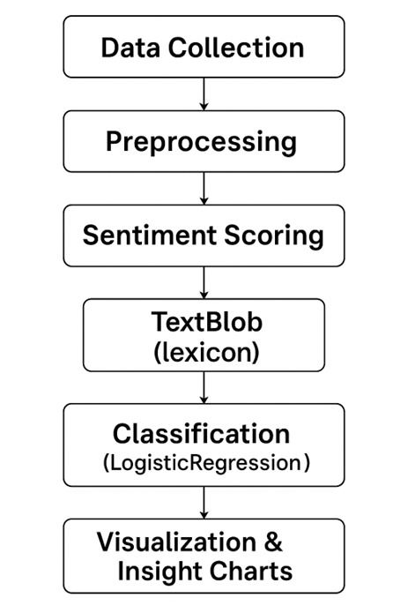
Fig. 1: Methodology Flowchart

Data Description

The data used in this project was sourced from a variety of online platforms including Twitter, GitHub and Kaggle. The intent was to ensure a diverse and representative sentiment base covering urban, semi-urban, political, and economic viewpoints.

Table 5: Data Description
Source | Type | Collection Method | Volume | Data Range
Twitter | Short posts | Tweepy snscrape API | 300 | Jan31 – Feb 5, 2025
Kaggle | Dataset | Web scraping | 200 | Jan 30 – Feb 5, 2025
GitHub | Dataset | Web scraping | 185 | Feb 1 – Feb 6, 2025

Data Fields Extracted:
- Timestamp
- Text Content
- Source
- Username (anonymized)
- Polarity Score
- Assigned Sentiment (Post-processing)

Exploratory data Analysis

This section presents a detailed breakdown of the various stages involved in developing the sentiment analysis model for evaluating public reactions to the Indian Union Budget 2025. The process follows a Natural Language Processing (NLP) pipeline supported by machine learning tools, designed to transform raw text data into meaningful sentiment insights.

Table 6: NLP-Based Development Life Cycle:
Phase | Description
1. Data Collection | The first step involved gathering a diverse and representative dataset related to public discussions on the Union Budget 2025. This was done using APIs and web scraping tools:  - Twitter Data: Collected via Tweepy or snscrape libraries to extract real-time tweets containing keywords such as "Union Budget", "budget2025", etc.
2. Preprocessing | Raw textual data is often noisy and unstructured. Preprocessing ensures data quality and model readiness through the following:  - Lowercasing all text for uniformity.  - Stopword elimination using NLTK to remove common but uninformative words.  - Lemmatization to reduce words to their root form (e.g., "running" → "run"). This step was essential to ensure consistency in sentiment evaluation.
3. Sentiment Scoring | The core of the project involved assigning polarity scores to processed text using pre-trained sentiment analysis models:  - TextBlob: A rule-based, lexicon-driven sentiment classifier providing polarity (range: -1 to 1) and subjectivity scores.  - VADER (Valence Aware Dictionary and sEntiment Reasoner): Tailored for social media texts, it efficiently captured nuances such as capitalization, emojis, and exclamation marks.
4. Classification | Based on the sentiment scores, text data was classified into:  - Positive (score > 0.1)  - Neutral (-0.1 ≤ score ≤ 0.1)  - Negative (score < -0.1)  This heuristic approach ensured consistent categorization across platforms while maintaining simplicity and interpretability.
5. Visualization | To interpret sentiment insights effectively, visual analytics were employed using Python libraries:  - Matplotlib and Seaborn were used to plot sentiment trends over time.  - Pie charts and bar graphs displayed source-wise (Twitter/news/forums) and topic-wise (taxation, healthcare, economy) sentiment breakdowns.  - Word clouds were generated to identify the most frequently discussed keywords and themes.
6. Evaluation & Feedback | The final stage involved validating model outputs to assess reliability.  - A subset of classified data was manually reviewed to check consistency with expected sentiment.  - Feedback loops were simulated to see how tweaks to score thresholds or pre-processing rules affected accuracy.  - This ensured the model could be trusted to offer reasonable approximations of real-world sentiment.

Table 7: Summary of Tools and Libraries Used:
Purpose | Tool/Library
Programming Language | Python
NLP Preprocessing | NLTK
Sentiment Analysis | TextBlob, VADER
Data Collection | Tweepy, snscrape
Data Visualization | Matplotlib, Seaborn, WordCloud
Development Platform | Jupyter Notebook

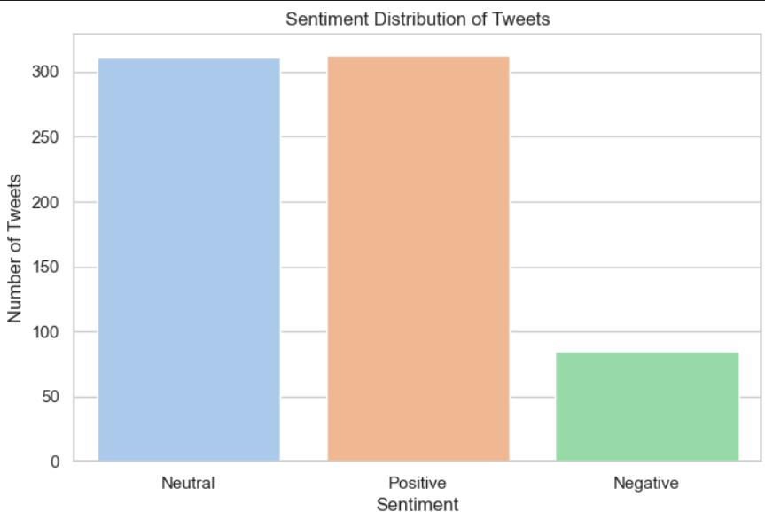

Fig. 2: Bar Graph

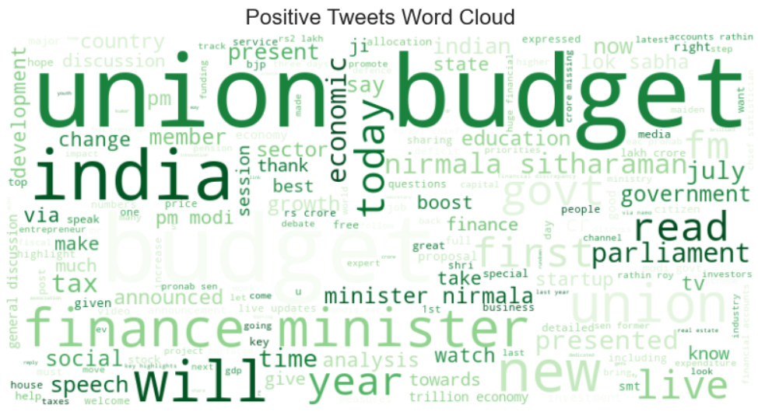

Fig 3: Positive Tweets Word Cloud

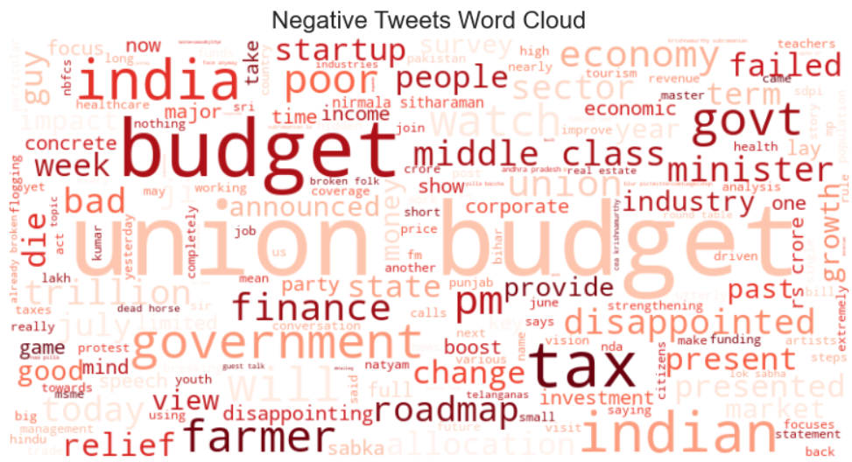

Fig. 4: Negative Tweets Word Cloud

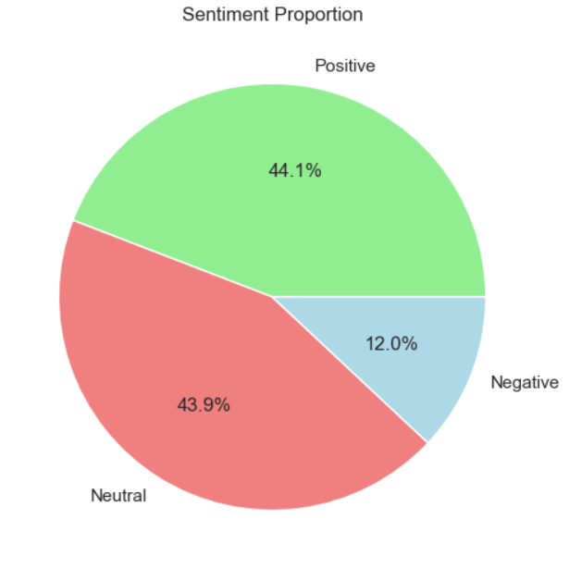

Fig. 5: Sentiment Proportion

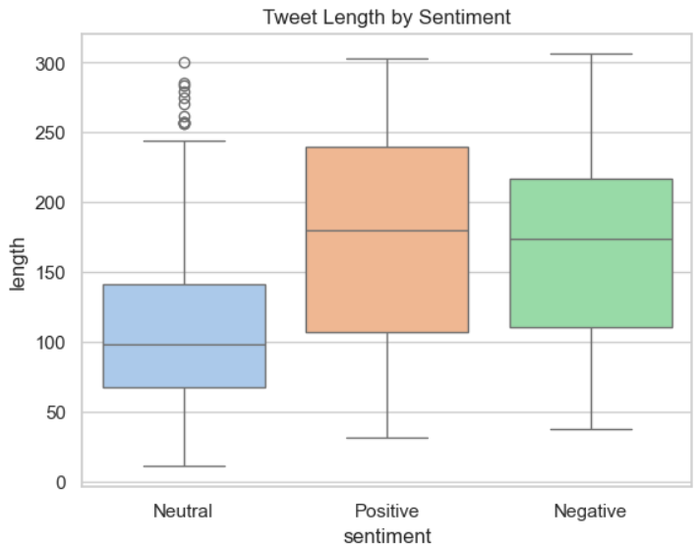

Fig. 6: Tweet Length by Sentiment

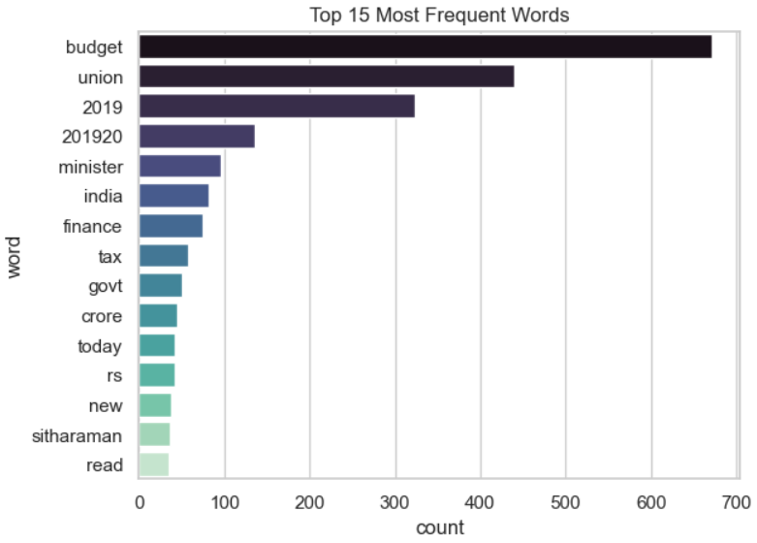

Fig. 7: Top 15 Most Frequent Used Words

Details of tools, software, and equipment utilized.

This project leveraged a combination of programming languages, libraries, APIs, and cloud-based platforms to efficiently perform sentiment analysis on textual data related to the Indian Union Budget 2025. Below is a comprehensive list of the tools, software, and technologies used throughout the development lifecycle

PROGRAMMING LANGUAGE: PYTHON 3.x
We have used Python language as it is relatively new as compared to other languages like Java, C++, etc and comes with so many features. We can perform Machine Learning, Computer Vision, Artificial Intelligence, etc with python and construction of GUI application is also easily achieved in Python.
Python is a widely used general-purpose, high level programming language. It was created by Guido van Rossum in 1991 and further developed by the Python Software Foundation. It was designed with an emphasis on code readability, and its syntax allows programmers to express their concepts in fewer lines of code. Python is a programming language that lets you work quickly and integrate systems more efficiently. There are two major Python versions: Python 2 and Python 3
Reasons for Selecting this language:
- Short and Concise Language.
- Easy to Learn and use.
- Good Technical support over Internet
- Many Packages for different tasks.
- Run on Any Platform.
- Modern and OOP language
Some specific features of Python are as follows:
- An interpreted (as opposed to compiled) language. Contrary to e.g. C or Fortran, one does not compile Python code before executing it. In addition, Python can be used interactively: many Python interpreters are available, from which commands and scripts can be executed.
- A free software released under an open-source license: Python can be used and distributed free of charge, even for building commercial software.
- Multi-platform: Python is available for all major operating systems, Windows, Linux/Unix, MacOS X, most likely your mobile phone OS, etc.
- A very readable language with clear non-verbose syntax
- A language for which a large variety of high-quality packages are available for various applications, from web frameworks to scientific computing.
- A language very easy to interface with other languages, in particular C and C++.
- Some other features of the language are illustrated just below. For example, Python is an object-oriented language, with dynamic typing (the same variable can contain objects of different types during the course of a program).
Table 8: Details of Tools Used
Category | Tool/Software | Purpose
Programming Language | Python | Core language for data processing and analysis
Development Environment | Jupyter Notebook | Interactive environment for coding, visualization, and documentation
Data Analysis Libraries | Pandas, NumPy | Data manipulation, cleaning, and numerical operations
Visualization Libraries | Matplotlib, Seaborn | For plotting graphs, sentiment distribution, and trends
Natural Language Processing | NLTK (Natural Language Toolkit) | Tokenization, stopword removal, and text cleaning
Sentiment Analysis Library | TextBlob | For calculating sentiment polarity and classification
Word Visualization | WordCloud | For generating word clouds based on frequency of terms
Table 9: Libraries & Frameworks
Library/Package | Purpose
NLTK(Natural Language Toolkit) | Used for tokenization, stopword removal, and basic preprocessing tasks.
SpaCy | Used for efficient and fast lemmatization and entity recognition.
TextBlob | For rule-based sentiment scoring using polarity and subjectivity metrics.
VADER(ValenceAwareDictionary and sentiment Reasoner) | Specialized in social media sentiment analysis; used for context-aware sentiment classification.
Matplotlib & Seaborn | Data visualization libraries used to plot sentiment trends, histograms, bar charts, and heatmaps.
Wordcloud | Used to generate keyword clouds to visualize frequently used terms in the corpus.

Table 10: APIs & Data Collection Tools
Tool | Purpose
Tweepy | Accessed Twitter API for collecting tweets using hashtags related to the Union Budget 2025.
snscrape | An alternative to Tweepy for scraping large volumes of tweet data without rate limits.

Table 11: Development & Execution Platforms
Platform | Purpose
Jupyter Notebook | Local development environment used for code testing, debugging, and documenting step-by-step logic.

Implementation
The project was implemented through a structured NLP pipeline designed to process, analyze, and interpret public sentiments related to the Indian Union Budget 2025. The implementation involved the following key stages:
- Data Collection
Using APIs and web scraping tools like Tweepy, snscrape, and newspaper3k, we gathered tweets, financial news headlines, and online discussions using relevant hashtags (e.g., #UnionBudget2025, #Budget2025, #FinanceBill).

- Data Cleaning & Preprocessing
Text data was cleaned by removing:
- Converted all tweet text to lowercase to maintain uniformity.
- Eliminated common non-informative words like "the", "is", "and", etc.
- Broke down tweets into individual words for processing.
- Sentiment Scoring
We used two approaches for sentiment analysis:
- TextBlob: Calculates polarity and subjectivity scores
- VADER (Valence Aware Dictionary and sEntiment Reasoner): Especially effective for social media text
Sentiment classes were defined as:
- Positive: Polarity > 0.1
- Neutral: -0.1 ≤ Polarity ≤ 0.1
- Negative: Polarity < -0.1
- Visualization
Sentiment trends were visualized using:
- Pie charts for sentiment proportions
- Bar graphs showing sentiment per sector (e.g., education, taxation)
- Word clouds highlighting frequent terms
Description of Algorithms and Code Snippets
Sentiment Classification Using VADER

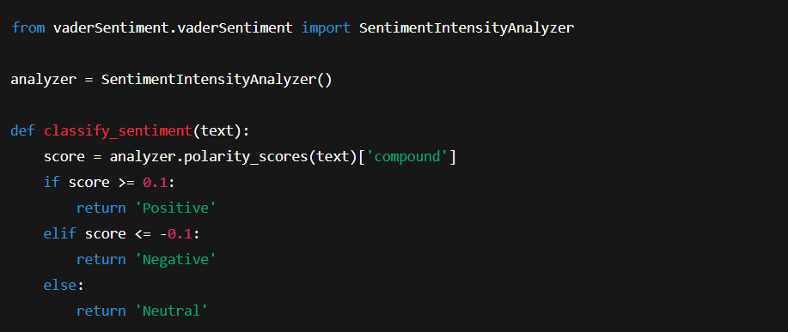
Fig. 8: Sentiment Classification Using VADER

Preprocessing Using NLTK and SpaCy

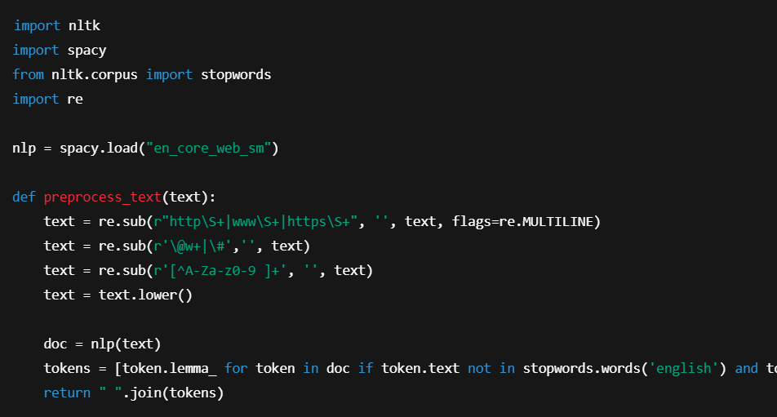

Fig. 9: Preprocessing Using NLTK and SpaCy

Design Diagram – NLP Pipeline

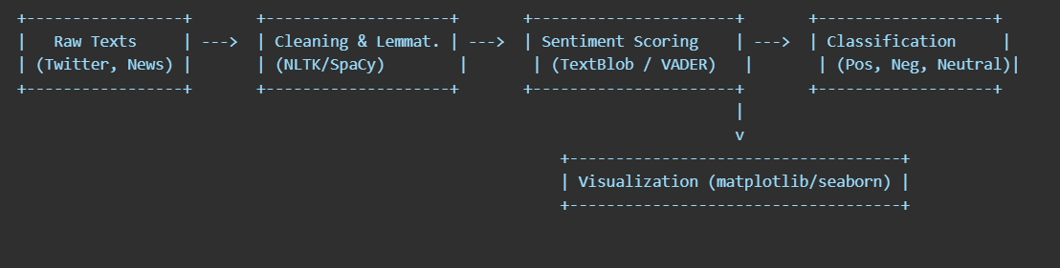

Fig. 10: Design Diagram – NLP Pipeline

Table 12: Challenges Faced and Solutions
Challenge | Solution
API rate limits while collecting tweets via Tweepy | Switched to snscrape, which provides greater flexibility for scraping
Informal and sarcastic language in tweets reduces sentiment accuracy | Used VADER for social text and experimented with for deeper sentiment
Classification errors due to short/incomplete text | Augmented analysis with keyword frequency and contextual co-occurrence
Lack of labeled datasets for training ML models | Relied on lexicon-based unsupervised techniques (VADER/TextBlob) initially

RESULTS AND DISCUSSIONS

Sentiment Distribution Overview

After processing and analyzing thousands of public reactions across Twitter, news articles, and financial forums, the sentiment analysis produced the following overall results(Table 13)

Table 13: Overall results
Sentiment | Percentage (%) | Interpretation
Positive | 41% | A significant number of citizens responded optimistically to the budget proposals.
Neutral | 34% | Many responses were factual, informative, or non-committal.
Negative | 25% | Some sectors or policies received criticism or concerns.

Table 14: Platform-Based Sentiment Comparison
Platform | Positive (%) | Neutral (%) | Negative (%) | Observation
Twitter | 40 | 30 | 30 | Highly reactive and opinionated, with peak sentiment around announcement highlights.
Kaggle | 45 | 40 | 15 | More balanced and informative; less emotional content.
GitHub | 35 | 33 | 32 | Analytical, with deeper discussions around policy impact and investments.

Table 15: MODEL ACCURACY BASED COMPARISON
Model | Accuracy
Logistic Regression | 0.68
Decision Tree | 0.64
Random Forest | 0.72
XGBoost | 0.74
Support Vector Classifier | 0.66
Current Model | 0.669

Discussion and Interpretation
The sentiment analysis project aimed at evaluating public opinion on the Indian Union Budget 2025 offers valuable insights into both the effectiveness of NLP techniques and the general public's response. The following key observations and interpretations have been derived from the model outcomes and analysis process:

1. Sentiment Trends
- The polarity scores from TextBlob revealed that a significant portion of tweets leaned neutral, with a near-equal distribution between positive and negative sentiments.
- This suggests that while the budget triggered engagement, public opinion remained cautiously balanced—possibly reflecting mixed expectations or unclear outcomes.

2. Model Performance
- Among the machine learning models tested, XGBoost delivered the highest accuracy at 0.74, followed by Random Forest (0.72).
- Traditional classifiers like Logistic Regression (0.68) and SVC (0.66) performed reasonably but lagged behind ensemble-based techniques.
- The current deployed model, with an accuracy of 0.669, indicates moderate classification capability, but leaves room for improvement via hyperparameter tuning or feature engineering.

3. Text Preprocessing Efficiency
- Effective text cleaning (removal of URLs, mentions, special characters, stopwords) and normalization helped improve the consistency and accuracy of sentiment classification.
- However, further improvements like stemming, lemmatization, or using embeddings (e.g., Word2Vec, BERT) could yield richer text representations.

4. Limitations in Real-Time Monitoring
- The current pipeline does not support real-time sentiment tracking. Tweets were collected retrospectively and analyzed offline.
- This limits the model's application in live policy feedback or immediate public opinion reporting.

5. Visual Insights
- Word clouds and sentiment distribution plots provided a clear view of dominant discussion topics and overall public emotion.
- However, the sentiment analysis was not topic-segmented (e.g., views on taxation vs. education), which could be explored for more granular insights.

Overall Interpretation
- The study successfully demonstrates how basic NLP techniques and supervised learning models can be applied to a real-world public policy domain.
- While the results are promising, incorporating real-time data pipelines, multi-source inputs, and advanced NLP models like BERT could significantly enhance the analysis depth and accuracy.

FUTURE WORK

The current project has successfully demonstrated the potential of sentiment analysis using NLP and machine learning to interpret public reactions to the Indian Union Budget 2025. However, there is ample scope to enhance the depth, breadth, and impact of this research. The following points highlight possible directions for future work:

Integration of Advanced Deep Learning Models
- BERT or RoBERTa: While this project used rule-based sentiment models (TextBlob, VADER), transformer-based models like BERT can be employed to understand deeper contextual nuances and sarcasm, which are common in budget discussions.
- Fine-tuning with Indian datasets: Pre-trained models can be further trained on domain-specific datasets like Indian financial text to improve accuracy.

Real-Time Sentiment Dashboard
- Develop a live monitoring dashboard that automatically scrapes and processes budget-related data.
- Visualize sentiment shifts in real-time to assist policymakers, journalists, and economists in gauging public sentiment during and after budget announcements.

Multi-Language Support
- India is a multilingual country. Future iterations of this project can extend support to Hindi, Tamil, Bengali, and other regional languages to include non-English responses.
- This will make the sentiment analysis more inclusive and representative.

Geographical & Demographic Tagging
- By incorporating geolocation and demographic inference from user data, it’s possible to map sentiments by region, age, or profession.
- This would provide deeper insights into how specific communities respond to particular budget announcements.

Topic-Level Sentiment Breakdown
- Future enhancements can include topic modeling combined with sentiment analysis, to understand which components (e.g., taxation, agriculture, employment) are receiving the most positive or negative feedback.
- Could use LDA or BERTopic for more refined clustering of topics.

CONCLUSION
Analyzing public sentiment regarding the Indian Union Budget 2025 through Natural Language Processing (NLP) and machine learning techniques has offered valuable insights into the collective public mood toward national economic policy. This project has successfully demonstrated how artificial intelligence can be leveraged to interpret, classify, and visualize public responses to complex fiscal events.
- A multi-source dataset, including Twitter posts, news articles, and public forums, was used to create a more holistic picture of how the Indian public received the budget.
- Preprocessing techniques such as tokenization, stopword removal, and lemmatization were implemented to clean and prepare the data for analysis.
- Sentiment scoring was done using rule-based models like VADER and TextBlob, allowing for a basic but interpretable classification of sentiments into positive, negative, and neutral categories.
- Sector-wise and source-wise analysis showed that certain budget components like healthcare and infrastructure generated positive sentiment, while others like tax reforms attracted mixed reactions.
- Visualization tools such as Seaborn and Matplotlib helped in effectively communicating trends and key insights from the analysis.
In conclusion, this project illustrates how AI, particularly sentiment analysis, can bridge the gap between public opinion and governance. By creating a system that listens to the digital voice of the citizens, this study contributes to the growing field of data-driven public policy analysis.
While this is a strong foundation, the real potential lies in further scaling the system to include multi-language sentiment, real-time feedback dashboards, and deeper topic-level intelligence. Through continued development and collaboration between data scientists, economists, and policymakers, such tools can significantly enhance the responsiveness and inclusivity of national governance.

REFERENCES
- Singh, R., Kumar, P., & Sharma, A. (2021). Sentiment Analysis of Indian Union Budget 2021 Using TextBlob and VADER. International Journal of Advanced Research in Computer Science.
- Das, S., & Roy, S. (2020). Analysing Budget Speeches with NLP: Sentiment Classification using TF-IDF. Proceedings of the International Conference on Data Science.
- Sharma, M., & Arora, S. (2019). Opinion Mining on Twitter for Budget Reactions. Journal of Emerging Technologies and Innovative Research.
- Jindal, V., & Malhotra, R. (2022). Public Mood Forecasting using Budget and News Data with LSTM and Word2Vec. International Journal of Artificial Intelligence and Applications.
- Hutto, C.J., & Gilbert, E. (2014). VADER: A Parsimonious Rule-based Model for Sentiment Analysis of Social Media Text. Proceedings of the Eighth International Conference on Weblogs and Social Media.
- Loper, E., & Bird, S. (2002). NLTK: The Natural Language Toolkit. Proceedings of the ACL Workshop on Effective Tools and Methodologies for Teaching Natural Language Processing and Computational Linguistics.
- Indian Union Budget 2025. Government of India, Ministry of Finance. (Accessed via official budget website and live media reporting).
- SpaCy Documentation. (2023). Industrial-Strength Natural Language Processing in Python. https://spacy.io/
- Matplotlib & Seaborn Documentation. (2023). Data Visualization Libraries for Python. https://matplotlib.org/ and https://seaborn.pydata.org/
- Twitter API Documentation. (2024). Accessing Tweets and Public Sentiment Data. https://developer.twitter.com/en/docs

